Hybrid image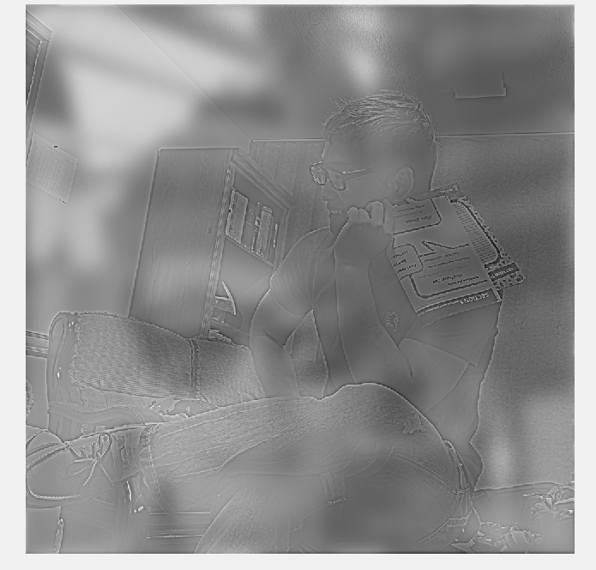

**HPF image:**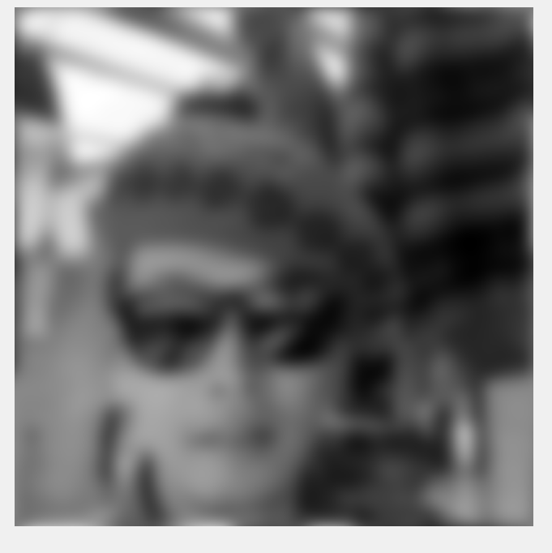

**LPF Image:**

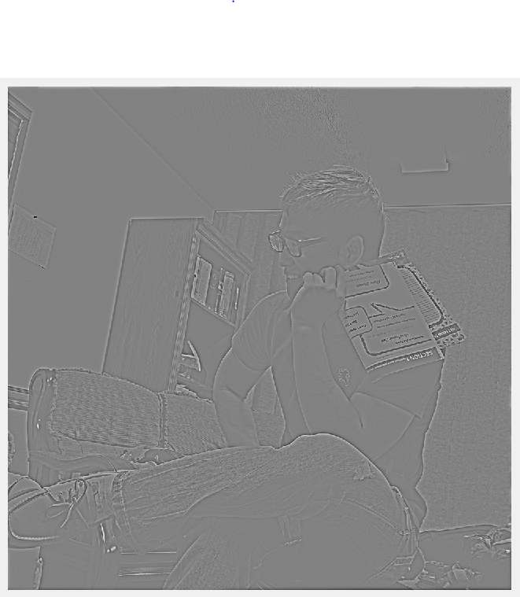

**Hybrid Image Source Codes:**

% load in my and friend's images

myImageDir='me3.png';

friendImageDir='friend.png';

% read it in and gray scale it

myImage=im2double( rgb2gray( imread(myImageDir) ) );

friendImage=im2double( rgb2gray( imread(friendImageDir) ) );

% setting gaussian matrix multiplication

sigma=6;

gaussianDim=3*sigma*2+1;

myImageHPFed=HPF(myImage,gaussianDim);

figure('Name','high pass filtered my image'), imshow(myImageHPFed,[]);

sigma=1;

gaussianDim=3*sigma*2+1;

friendImageLPF=LPF(friendImage,gaussianDim);

figure('Name','low pass filtered friend image'), imshow(friendImageLPF,[]);

hybridedImage=friendImageLPF+myImageHPFed;

figure('Name','Hybrided Image'), imshow(hybridedImage, []);

**high pass filter function source code:**

function HPF_Image=HPF(image,filter_size)

% fouier and shift the image

fourierImage = fft2(image);

fourierShiftedImage=fftshift(fourierImage);

% alloting size of image

[i ,j]=size(fourierImage);

% looping through the iteration

X=0:j-1;

Y=0:i-1;

% mesh grid

[X, Y]=meshgrid(X,Y);

Center_of_x=0.5*j;

Center_of_y=0.5*i;

% h(t) for fourier transformation

G=1-exp(-((X-Center_of_x).^2+(Y-Center_of_y).^2)./(2*filter_size).^2);

% fourer transform and shift for High Pass Filtered Images

fourierFilterImage=fourierShiftedImage.*G;

fourierFilteredShiftedImage=ifftshift(fourierFilterImage);

HPF_Image=ifft2(fourierFilteredShiftedImage);

end

**LPF function source codes:**

% function for images undergoing low-pass filter

function LPF_Image=LPF(image,filter_size)

% fourier and shifted

fourierImage = fft2(image);

fourierShiftedImage=fftshift(fourierImage);

% size of the image

[i, j]=size(fourierImage);

% iterating through matrix to add values

X=0:j-1;

Y=0:i-1;

% mesh grid

[X, Y]=meshgrid(X,Y);

Center_of_x=0.5*j;

Center_of_y=0.5*i;

% h(x) to be used

G=exp(-((X-Center_of_x).^2+(Y-Center_of_y).^2)./(2*filter_size).^2);

% fourier transform and shift for low pass filter process

image_FFT_filtered=fourierShiftedImage.*G;

image_FFT_filtered_shifted=ifftshift(image_FFT_filtered);

LPF_Image=ifft2(image_FFT_filtered_shifted);

end